 **BBQ Pits by Klose 1355 Judiway Street #B**

**MAIL ORDER/ ORDER BY PHONE Houston, TX 77018 USA**

**Visa/ Master Card/Discover/AMEX Factory: 1-713-686-8720**

**Lay-Away/Financing/Debit Card Fax: 1-713-686-8793**

**Member: Better Business Bureau Call: 1-800-487-7487**

**Thousands of Trophies Won Call For Pictures & Descriptions**

**Grills & Backyard Smokers Delivery Available World-Wide**

**Restaurant & Commercial Units Call for Discount Delivery Rates**

**Mobile Cook-Off/Catering Rigs/--Chuck Wagons---/Train & Pistol Cookers**

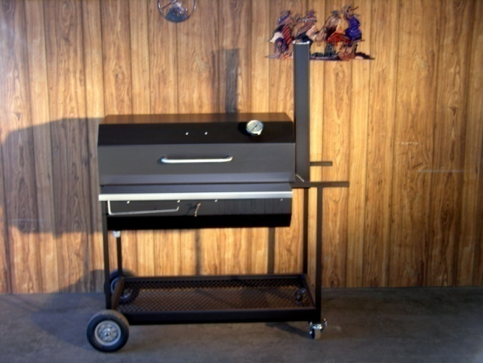 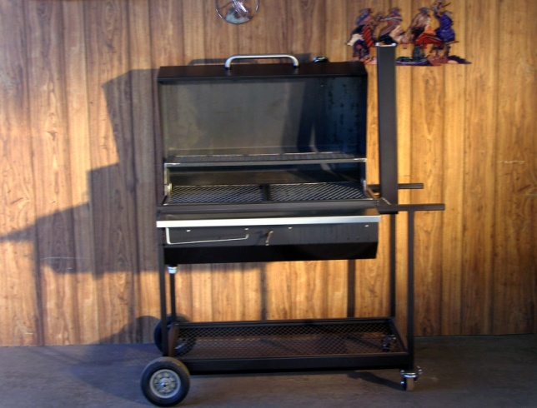

**The New 20x36 Square Grill Total Length including handles 48 inches**

**Full Log Rack 20 inches by 36 inches long. Top of stack is 58 inches/ 32” Depth including wheels.**

**Main cooking area has 2 piece meat racks framed in steel angles for strength, & removable ½ Shelf.**

**All New Steel on Square Pits is 12 gauge for the Grills, 3/16” on the fireboxes, & 14 gauge on the SS**

**Heavy Duty Stainless Steel Handle & Door Hinges 8 inch x 34 inch Solid SS Front Table**

**BBQ Pits by Klose SS Thermometer included Hand Crank Adjustable Height Fire Rack Included**

**Four Wheels, 4 Utensil Hooks, SS towel holder Also has a Solid Steel Ash Charcoal Pan 12” x26”**

**SS adjustable air-intake & smokestack controls. Weight is 260 Pounds-Price for 2016 is 1195.00**

**Rotisserie Option 795.00**

**JUST OUT NOW 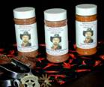 NEW NEW NEW**

**BBQ Pits by Klose Award Winning Championship Seasonings**

***Folks, these are the Best Three Seasonings I have seen in 20 years.***

***Handmade Fresh at our Factory Weekly with the Very Best of Ingredients.***

***Already First Place Brisket, Chicken, & Rib Winners.***

***Dave’s Championship Brisket Rub, Poultry Rub, & Pork & Rib Rub*.**

**100% of All Seasonings in Stock All the Time.**

[**david@bbqpits.com**](mailto:david@bbqpits.com)[**www.bbqpits.com**](http://www.bbqpits.com/)

***A full packed 16 ounce net wt. of Seasoning in a clear Bottle with a Pour & Shaker Top for 11.75 each***

***Gift Packs of any Three are 29.95***

***Bulk Packs Available in 10# Minimum Orders per Spice (8.95 per Pound)***

***+ S&H (In Stock All the Time/ Made Fresh Weekly/Shipped out Daily.)***

**Ask for the NEW BBQ Pits by Klose Seasonings, Gift Packs, & BBQ Accessories.**