BARBECUE PITS BY KLOSE-DELIVERY WORLD WIDE
BBQ Pits by Klose 1355 JUDIWAY STREET #B Houston, Texas 77018-6005
Phone: 713-686-8720 Factory Floor Fax: 713-686-8793 Toll Free: 1-800-487-7487
Website: WWW.BBQPITS.COM Email: david@bbqpits.com
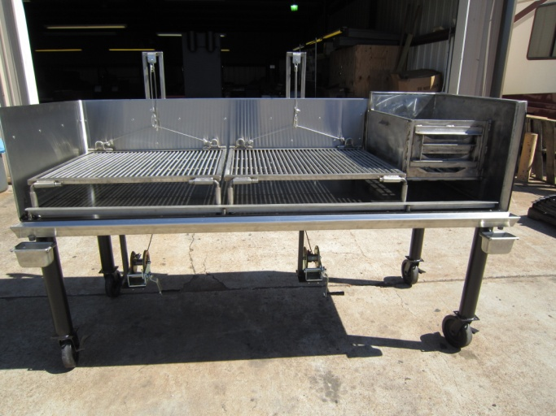
An Amazing New Design Open Grill with all Stainless Steel interior Liners, Firebox, & Meat Racks.
Front SS Removable Drip Shield, Catch Pans, & SS Angle Hot Coal Guard/
Firebox Rack with Removable SS Solid Sides. Built to Last A Lifetime of Use.
Boat Winches with SS Cable to Elevate the Rear of the SS Meat Racks for Food Product Displays.
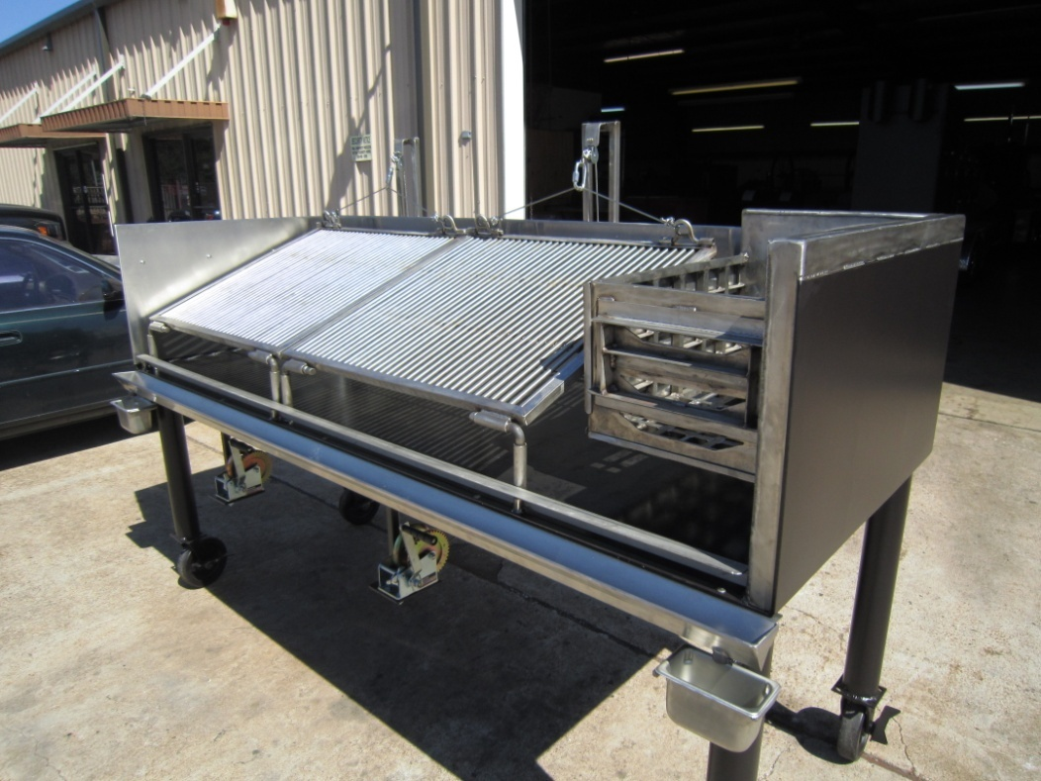
BARBECUE PITS BY KLOSE-DELIVERY WORLD WIDE
BBQ Pits by Klose 1355 JUDIWAY STREET #B Houston, Texas 77018-6005
Phone: 713-686-8720 Factory Floor Fax: 713-686-8793 Toll Free: 1-800-487-7487
Website: WWW.BBQPITS.COM Email: david@bbqpits.com
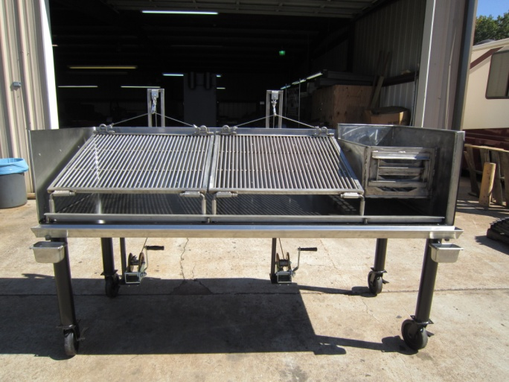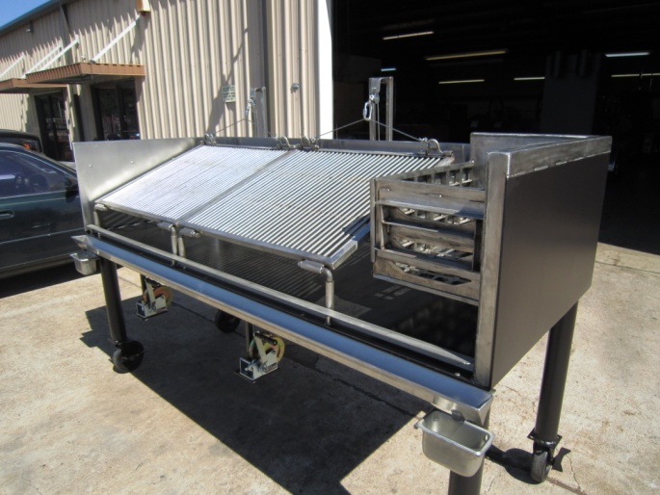

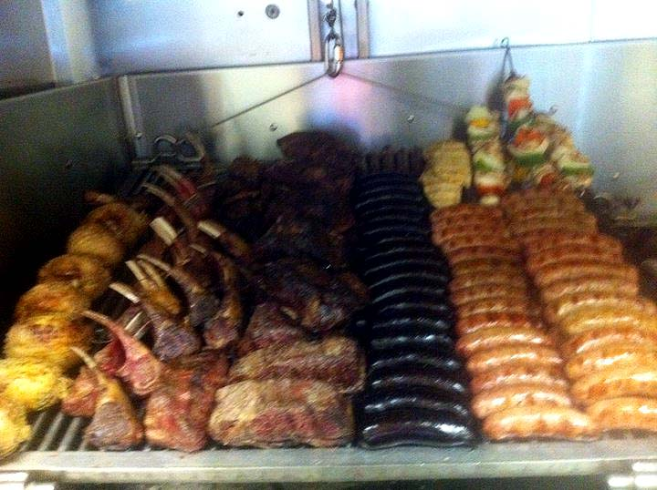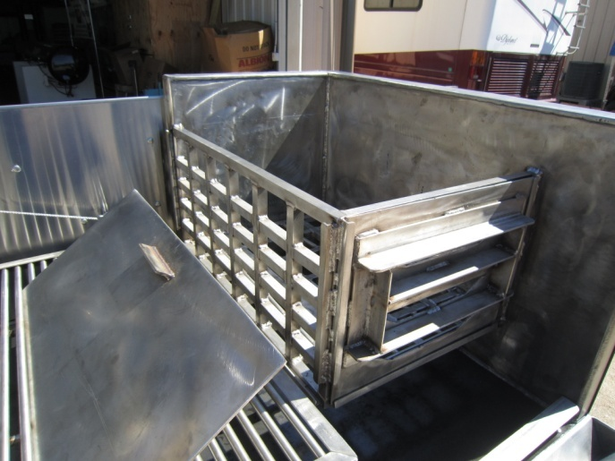
An Amazing New Design Open Grill with all Stainless Steel interior Liners, Firebox, & Meat Racks.
Front SS Removable Drip Shield, Catch Pans, & SS Angle Hot Coal Guard 17,975.00
Firebox Rack with Removable SS Solid Sides. Built to Last A Lifetime of Use.
Boat Winches with SS Cable to Elevate the Rear of the SS Meat Racks for Food Product Displays.
HOT COAL BED RACK ON BOTTOM OF FIREBOX MADE FROM 1-1/2” THICK STEEL
36” deep by 8 foot long open grill with 14” tall sides, on 8” locking swivel caster legs
outside A36, grade new steel plate & painted food grade BBQ Black
Legs made from 3” x ¼ wall steel pipe & painted food grade BBQ Black
Firebox Solid Stainless Steel, & double wall SS lined 2” thick with rock wool Insulation,
Now Comes With 3/8” Ss Plate 16” Over Firebox To Protect Ansel Supression Systems.
304 stainless steel components:
Full Interior Liner of ¼” Thick Stainless Steel riveted with SS Rivets
Removable 4” deep V-grooved grease drain attached to front of grill w/ ss drip catch’s
Meat racks made from 1” ss angle framing ½” ss solid round bars,
allowing to be tilted up 35 degrees on ss cable for display
Fire rack made from solid ss plate & angles, with removable solid ss plate sides.
Other components: Two Standard 2,000# boat winches w/ SS Cables
